**Employee Database: User Guide**

Hi! This user guide for the Employee Database program will go through all the things you need to know to be able to use the database successfully. To ensure you have all the files to be able to start, here’s a list of the files you should have (this is more for a developer, but just in case):

* EmpDB.form
* EmpDB.java
* EmployeeInfo.java
* FullTimeEmployee.java
* map.png
* mapBrampton.png
* mapCaledon.png
* mapMarkham.png
* mapMississauga.png
* mapToronto.png
* mapVaughan.png
* MyHT.java
* PartTimeEmployee.java

Once you have these files, run the program. This database will allow you to add employees (of two kinds: part-time and full-time), search to see if an employee is in your database or not, modify employee data, remove employees, and finally, read and write all this data from/into a text file. This document will guide you through each process.

First, after running, your program should pop up in a window that looks like this:

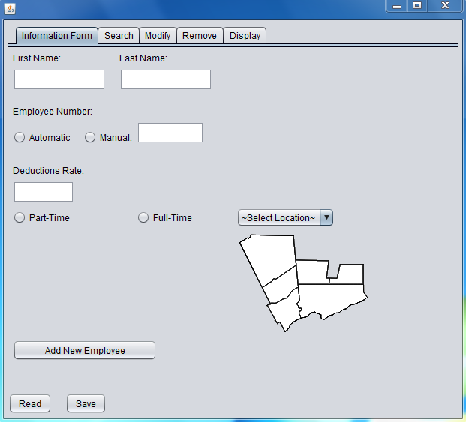

**Adding:**

The program begins on the tab that will allow you to add an employee, “Information Form”. To use any of the other parts of the program, you simply click on the other tabs at the top, for “Search”, “Modify”, “Remove”, and “Display”. At the bottom, you have “Read” and “Save”, which can be used on any tab. Of course, when you’re starting out the program, you won’t be able to search for anyone, modify anyone, remove anyone, and you’ll be displaying no employees. However, if you’ve written the data of employees on the text file (correctly), the first thing you’d like to do is click “Read” so that you can begin the program with the data of all the employees previously entered. Reading will be further discussed later; for now, let’s see how you would add an employee to the database.

  
 These two boxes are where you enter the employees first and last name, respectively. You will be able to enter any kind of text, even ones not commonly used in names; it is expected that you enter in the name correctly, but if you make a mistake, it can be fixed later through “Modify.” Also, you cannot leave these boxes (or any boxes in the information form) blank, otherwise an error message will occur.

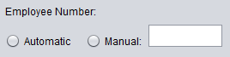

Next, you will enter the Employee’s employee number. If you want, you can click “Automatic”, and the program will generate an employee number for you, starting at 1 and counting up until it finds an employee number not currently used. If you wish to manually enter an employee number, you can do so as well. You must enter a positive integer only (or zero) as an employee number, and ensure that another employee with that number does not already exist. If one does, the program will send an error message. Note that employee number cannot be changed even when modifying an employee.



This is the deductions rate for an employee’s income. It must be a number between 0 and 1, and it can be 0, but it cannot be 1.



Here, you choose if the employee you’re adding is part-time or full-time. If they are part-time, they will have an hourly wage, hours worked per week, and weeks worked per year. If they are full-time, they have an annual salary. All of these can be any real number greater than zero.

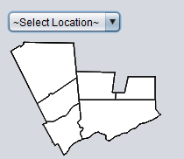

Clicking on the drop-down menu will allow you to choose the location of this employee. Additionally, that location will be highlighted on the map below the menu. You can choose from the following locations: Toronto, Mississauga, Brampton, Caledon, Vaughan, and Markham.

After all information has been entered, you can click on the “Add New Employee” button:



If everything was done correctly, a message saying that the employee was successfully added will appear for a second in the top right corner of the tab. If not, an appropriate error message will appear, and you will have to correct the data so that it can be entered. Once an employee has been added, you can modify them, remove them, view them on display table, if you search for them they will be found, and, you can save the file so that the next time you run the program, you can read their data instead of having to enter it again.

**Searching:**

This tab will allow you to search for an employee number to see if they are in the database. However, it will only tell you whether they are in the database or not; to view their information, the modify tab will have to be used.

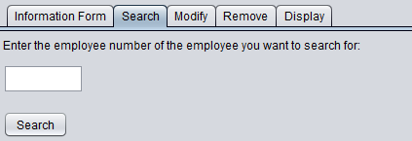

After clicking search, a message will show up that will tell you whether they are in the database or not. Similar searches will be used in the “Modify” and “Remove” tabs.

**Modifying:**

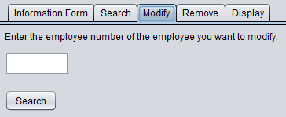

Just like in the Search tab, first you search for the employee you wish to modify. If that employee is found, the following message appears under the Search button, and you have the option to view that employee’s data (and modify it, if you wish), or to not cancel the modification. Note: do NOT switch tabs if the search is successful, until you click cancel, otherwise the program may behave strangely.

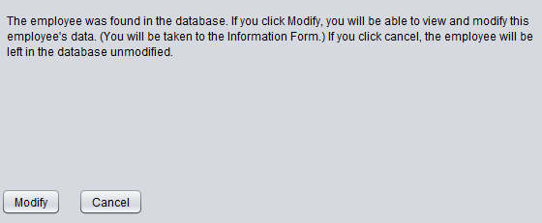

If you click Modify, you will be taken to the Information Form. However, to ensure that modifying and adding are done separately, when viewing/modifying the data, you will not be able to switch tabs, and two new buttons appear at the bottom of the tab:



The only way to be able to switch tabs is by clicking one of these buttons. Clicking “Cancel” leaves the employee as they were originally, regardless of if you’ve made any modifications in the Information Form. If you have made modifications, and you click Modify Employee, then the program will first ensure all data is in the correct format before allowing the employee to be modified. If it is, the employee will be modified, and a new row for that employee will be added into the display table, while their previous row will be deleted. (Note: this means that if previously the employee was in the first row, for example, now they would be in the last row.)

**Removing:**

Like the previous two tab, to remove an employee you must first search for them. If after searching, the employee is found, the following message will appear (this example uses an employee with employee number 1234, first name “Guy”, last name “Wun.”):

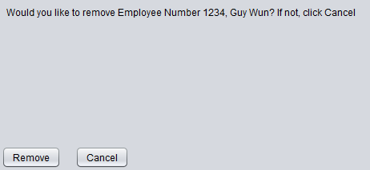

Clicking remove will remove the employee from the database, while clicking cancel will do nothing and keep them there. Like before, do NOT switch tabs until you click one of these buttons.

**Displaying:**

This tab displays all information of the employees currently in the database on a table, except the information specific to part-time (wage, hours per week, weeks per year) or full-time (salary) employees. However, this tab also shows the Net Annual Income, not shown in any other part of the program. (It is rounded to two decimal places). This is calculated for part-time employees by multiplying hourly wage by hours per week by weeks per year, and then multiplying that by one minus the deductions rate. Similarly, for full-time employees, it is calculated by multiplying their salary by one minus the deductions rate. Here is a sample of how a display table with four employees may look like:

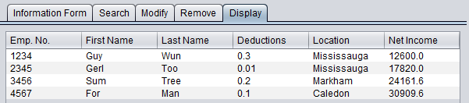

**Saving & Reading:**

The two buttons at the bottom of the program, regardless of the tab, are the ones that will allow you to save the data you’ve added to the database, and to read this data when opening the program so it does not have to be re-entered every time.



The first time that you open the program, after you finish adding all employees and want to save their information, you click “Save” to do so. If it returns an error message, contact the developer at [*m.amjad.umer@gmail.com*](mailto:m.amjad.umer@gmail.com)*.* Given test runs, however, this should not return an error for any reason. Once you have done this and you close the program, and then you re-open it any time later, then you must clicked “Read” as soon as the program is opened if you wish to keep that information. This is because when you read from the text file, all current information in the database is deleted, and then replaced with the information in the file. Similarly, when you save from a file, all information in the file is deleted, and then replaced with the information in the database. Thus, one must always be careful when saving and reading, and keeping back-ups of the text file is recommended. The text file is found in the project folder, (called Employee Database), and is named EmployeeDatabase.txt. If one knows the file format (described below), then one can manually enter information into the text file so that when reading it can be added to the database. However, it is easy to make errors while doing so, and the program will not read anything if an error is made. Additionally, as said earlier, the program will erase all data in the program before reading, even if there is an error.

**File Format**

The text file is found in the project folder, (called Employee Database), and is named EmployeeDatabase.txt. The following describes how the text file is formatted, with each line explained in curly brackets, {}. Locations 0 to 5 correspond to Toronto, Mississauga, Brampton, Caledon, Vaughan, and Markham respectively. If any of these are not in the correct format as described in the “Adding” section about the Information Form, there will be an error while reading.

{number of employees in file}

{Employee number (of the first employee)}

{first name}

{last name}

{deductions rate}

{location, as integer}

{“P” if employee is part-time, “F” if employee is full-time}  
  
If part-time, the next lines are:   
{hourly wage}

{hours per week}

{weeks per year}

If full-time, the next lines are:

{annual salary}  
  
And this continues with {Employee number (of the second employee)} and so on, until the number of employees in the file is met.   
The following is a sample for the text file, containing the information for the sample table shown in the “Displaying” section:

4

1234

Guy

Wun

0.3

1

P

15.0

40.0

30.0

2345

Gerl

Too

0.01

1

P

15.0

40.0

30.0

3456

Sum

Tree

0.2

5

F

30202.0

4567

For

Man

0.1

3

F

34344.0

**Contact: if you have any queries, the developer can be contacted at** [**m.amjad.umer@gmail.com**](mailto:m.amjad.umer@gmail.com)**.**